Case 1-Eur-Czech Republic, Moravia, Střelice, Venus Figurine
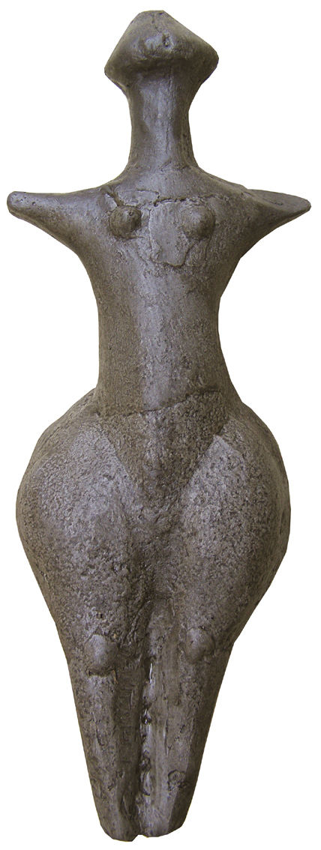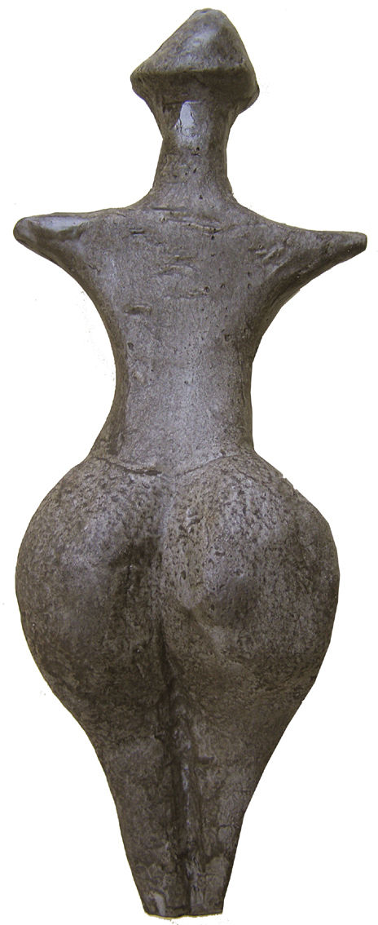
Formal Label: Czech Republic, Moravia, Střelice, Venus Figurine
Accession Number:
LC Classification: GN772
Date or Time Horizon: 4,700 - 4,300 BCE
Geographical Area: Republic, Moravia, Střelice
Cultural Affiliation: Neolithic
Medium: Fired clay
Dimensions: H 22 cm (8.7 in)
Weight:
Condition: Resin replica of original
Provenance:
Discussion:
References:

